UNCONFIRMED MINUTES
NOVEMBER 11, 2015
WEBEX / TELECONFERENCE CALL

These minutes are not final until confirmed by the MedAccred Management Council in writing or by vote at a subsequent meeting. Information herein does not constitute a communication or recommendation from the MedAccred Management Council and shall not be considered as such by any agency.

WEDNESDAY, NOVEMBER 11, 2015

OPENING COMMENTS

Call to Order / Quorum Check / Introductions

The MedAccred Management Council (MMC) WebEx & Teleconference Meeting was called to order at 11:00 a.m. EST, 11-Nov-2015, with the following representatives in attendance:

MMC Members Present

NAME |  | TITLE | COMPANY NAME
George | Abouzeid | Corporate Compliance Manager | Medtronic
Ed | Engelhard | Corporate Quality Manager | Solar Atmospheres
Scott | Goolsbey | Supplier Controls Manager - Stryker Endoscopy | Stryker Corporation
Ravi | Nabar | Head of Supplier Quality Assurance | Philips HealthTech

PRI Staff Present

Jerry | Aston | Associate Program Manager, Heat Treating | PRI
Mark | Aubele | Senior Program Manager, Staff Engineer, Sterilization | PRI
Connie | Conboy | Director, Strategy and Business Development | PRI
Susan | Frailey | Lead Staff Engineer – MQS | PRI
Hannah | Godfrey | Senior Specialist, Business Development Europe, MedAccred Co-Lead | PRI
Joanna | Kennedy | Manager, Communications and European Customer Relations | PRI
Bob | Lizewski | Quality Manager, Industry Managed Programs | PRI
Julia | Markardt | Staff Engineer, PCBA and C&WH | PRI
Justin | McCabe | Senior Specialist, Business Development, MedAccred Co-Lead | PRI
Kellie | O’Connor | Program Coordinator, Nadcap & MedAccred | PRI
Ian | Simpson | Associate Program Manager, Welding | PRI

Connie Conboy reviewed the meeting agenda.

Code of Ethics, Anti-trust and Conflict of Interest

Justin McCabe reviewed the PRI Code of Ethics, Anti-trust and Conflict of Interest policy. There is also a video regarding this information, which is shown at each face-to-face meeting. To view the video, please use the following link: https://www.youtube.com/watch?v=skr4dB9YE8c&feature=youtu.be

Approval of MMC Minutes

Following review of the October 2015 Minutes, three changes were proposed:

- Add Mark Aubele as an attendee
- Add a note regarding confirmation that the FDA will not use any information from the outcome of an audit in the event they would observe an audit
- Add a note regarding the conversation around the possibility of FDA observing a Nadcap audit, and how the FDA would be most interested in observing a medical device supplier and not an aerospace supplier

Motion made by Ravi Nabar and seconded by Ed Engelhard to approve 01-Oct-2015 teleconference minutes with the proposed changes listed above. All in favor and minutes were approved.

Marketing and Trade show update

Connie Conboy provided a summary of marketing opportunities and trade shows where MedAccred had or will have a presence.

AdvaMed 2015 (5-7Oct15)
There were a number of positive outcomes from this conference, including:
- Key Medical Device insurance company considering a 10% reduction in liability insurance for suppliers with MedAccred critical process accreditation
- Key supplier interested in promoting their Accreditation
- Key CM interested in rolling MedAccred out across their supply chain
- AdvaMed’s Library of Successful Quality Practices – MedAccred highlighted
http://advamed.org/res/975/medaccred-supply-chain-accreditation-information

MD&M West 2016 (9-11Feb16)
MedAccred will be participating in the MD&M West show in 2016, including the following activities. If anyone would like to participate or be involved, please contact Connie Conboy or Justin McCabe.

- Conference Presentation (11Feb15)
- MedAccred Lunch & Learn (10Feb15)
  - Invitation only event for 50 key individuals
  - Companies are invited to ‘host’ a lunch table (no costs involved as event is pre-paid). Opportunity to invite colleagues or representatives of key suppliers to attend and learn more about MedAccred

Implants 2016 – Paris, France (7Jun16)
Simon Adam from DePuy-Synthes has been invited to give an address at this conference, where he will highlight MedAccred. MedAccred will also have a micro-booth at the conference to provide additional information.

Publications

ODT magazine is in the process of publishing an in depth article on the MedAccred process.

Controlled Environments Magazine - Article on Surface Cleaning, Connie Conboy and Julia Markhardt were interviewed regarding Printed Circuit Board Assemblies.

SOCIAL MEDIA OUTREACH

Hannah Godfrey gave an update on some of the MedAccred social media activity that has taken place in the last six months. Please see the embedded slides for more information.

MMC and other MedAccred participants are encouraged to follow and like the pages on LinkedIn and Twitter, as well as liking, sharing and/or retweeting any posts on either site, which will help us to spread information about MedAccred and reach a broader audience.

Note that MedAccred is listed as a Company on LinkedIn so to find the page it is easiest to search this category for ‘MedAccred’.

Task Group HIGHLIGHTS

PRI Staff Engineers provided updates on the status for their respective Task Group activities.

Welding (WLD)

The Welding Task Group has completed the handbooks for their laser welding checklists. Upcoming project includes revision of the fusion checklist to add an additional sub-process.

Sterilization (STN)

All three checklists currently in ballot to the Task Group and will close Friday, 13-Nov-2015. It will subsequently be sent on a 14-day affirmation ballot to the MMC next week. If there are no comments and it is approved, the checklists will be uploaded and effective before year end, with a target of 01-Dec-2015.

The Task Group is currently working on its first accreditation audit, which was conducted as a paper audit. Once all the findings are resolved, and the checklists are effective, the paper audit will be uploaded into eAuditNet and the company will then be accredited.

One auditor in the system was rejected at the stage 1 interview. One additional auditor is scheduled for a stage 1 interview. The requirements documents created by STN will be reviewed at the next conference call.

Plastics (PLA)

Continuing to work on Injection Molding criteria, agreed to include a few other molding processes in the checklist, including insert molding, over molding, injection blow molding, transfer molding and compression molding. Initial target is year end. They are also working on Auditor qualifications and beginning the recruitment process..

The Task Group is working to identify a supplier to conduct the first pilot audit.

Printed Circuit Board Assemblies (PCBA)

Introduced the b-form, which allows anyone on the Task Group to suggest an improvement to the checklist. The Task Group will likely make their first revision to the checklist sometime in 2016.

MedAccred Quality Systems (MQS)

The checklist is approved and published, and the Task Group is now waiting for audits.
They are currently looking for MQS auditors for each of the current MedAccred Task Groups, so if the Staff Engineers for those groups know of any auditors who may be interested, please let Susan know.
Additionally, the Task Group is still looking for a Chairperson, as discussed at last month’s face-to-face meeting. If any MMC members have anyone in mind whom they would like to nominate as Chair for this group, please notify Justin McCabe or Susan Frailey.

Heat Treating (HT)
There are no new updates since the last meeting, and the Task Group is waiting for audits to be scheduled.

Cable & Wire Harness (CWH)
The Task Group is meeting regularly and is working on handbooks as well as a b-form similar to the PCBA group. Global Technologies would like to have their 1st audit early next year.

MMC Sub-Teams Update

The Process Validation Sub-Team is working on the following two topics:

Audit Criteria Development

General - Reviewing new questions covering: “Environmental Testing” and “Risk Control”

Training

Sub-team has been formed to develop training material for Auditors, Staff Engineers and other Stakeholders

Ravi Nabar suggested that perhaps this sub-team should have a second phase, where the team would work to create a standard set of process validation documents, which would be agreed upon by Subscribers, and which could then be audited for completeness. This would provide clear guidance to suppliers as well as auditors.

The importance of training on process validation for auditors and PRI Staff Engineers was stressed by Ed Engelhard and Ravi Nabar.

2015/2016 MMC MEETING DATES/LOCATIONS

Participants were emailed asking for the better date/location for the next face-to-face meeting. Following the vote, Anaheim, California in early February 2016 may be the best option, in conjunction with MD&M West. This would also be beneficial as we could then get the participation for the planned MedAccred activities during the show that week.

The MMC agreed to hold the next face-to-face meeting on February 9th or 11th, 2016 in Anaheim.

OTHER business

Ed Engelhard noted that in Nadcap, there is an Audit Observation program, which is done by Subscribers to ensure the audit is conducted according to operating procedures. With that in mind, Solar Atmospheres are issuing an invitation to MedAccred Subscribers to observe their first reaccreditation audit, so they can see the audit as it takes place. This audit is currently scheduled to take place from January 11-14 2016 at their Souderton, PA facility.

If any Subscribers are interested in attending they should contact Justin McCabe.

RAIL REVIEW

Hannah provided a quick RAIL update. Please see the table below for details.

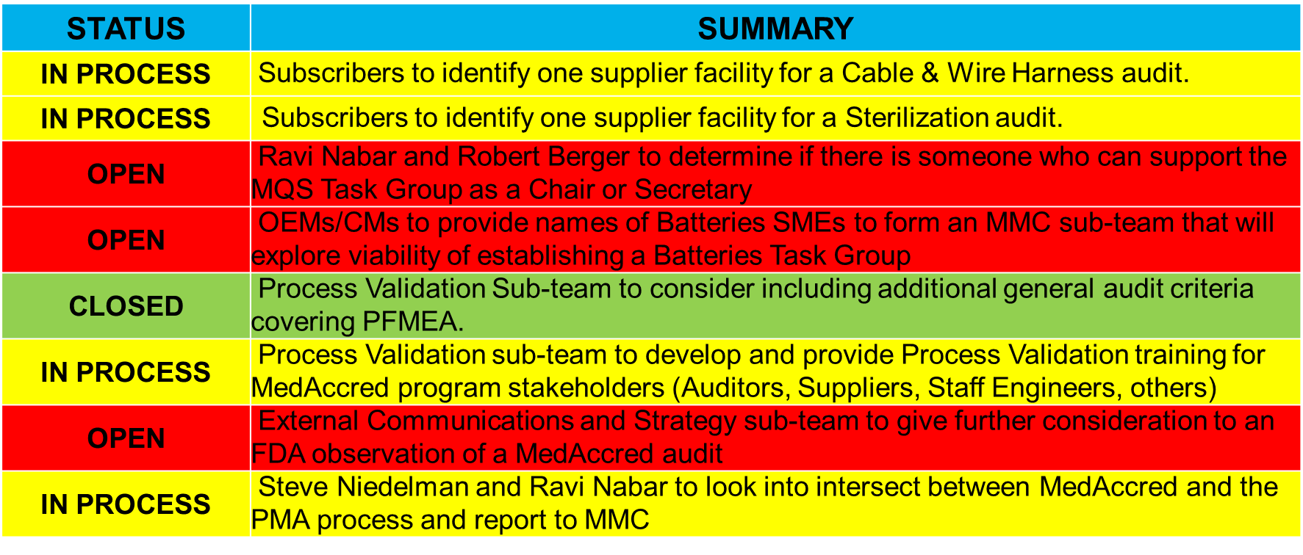

ADJOURNMENT – 11-Nov-2015 – Meeting was adjourned at 12:00 p.m.

Minutes Prepared by: Kellie O’Connor, koconnor@p-r-i.org

